**ZS Smart on FHIR App web client**

**Introduction**

This Document will walk you through creating a web client to interact with Cerner’s Smart on FHIR ecosystem.

**Prerequisites**

1. Install Python 3.9+ in your machine.
2. Install PyCharm IDE for development and execution.

**Registration**

Create a new account on <https://code.cerner.com/developer/smart-on-fhir/apps> or login if you are already registered. Once logged into the console, click on the “+ New App” button in the top right toolbar and fill in the following details:

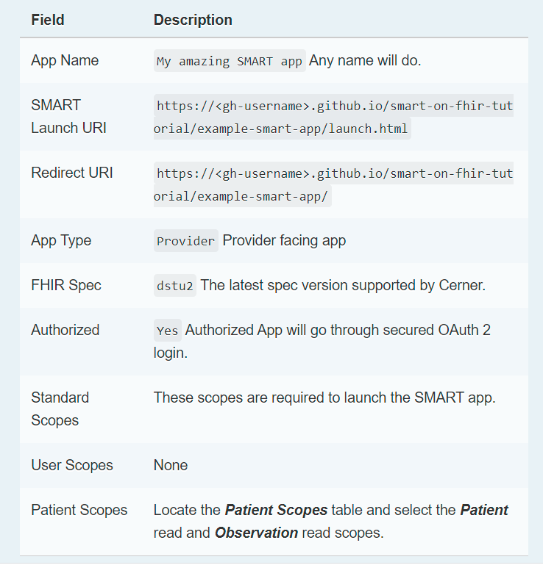

This scope can be added according to requirements

Refers to type of smart app we are creating it can be Provider, Patient or System app

http://127.0.0.1:8000/result

http://127.0.0.1:8000/

Complete the above steps and click on register.

Note the client id , app id once app is registered successfully.

**\*\*http://127.0.0.1:8000 – refer to the local address for our application. This will be different if you deploy the app on different servers.**

**App Deployment Steps –**

1. Download the project code from [link](https://bitbucket.org/ssmeltz/interop-platform/src/f6b0b5e28db1d8e7695e803139bce18dcadeaef9/fhir-patient-browser/?at=feature%2FInterop-module)
2. Go to project path e.g.- D:\Projects\HPP\FHIR\Workspace\Smart FHIR App\smartapp
3. Download the required python libraries by executing command - pip freeze > requirements.txt
4. Open auth.html file from path - \smartapp\app\templates\app\auth.html
5. Replace the client id with your app client id.
6. Replace Patient_id with your pid and add the similar scope which you have defined while registering the application
7. Navigate to path \smartapp and execute the command **python manage.py runserver** to start the application.